Course: Data Science Roll No: TYCS-12

Aim: Practical on Principal Component Analysis.

__________________________________________________________________________________

Output 1

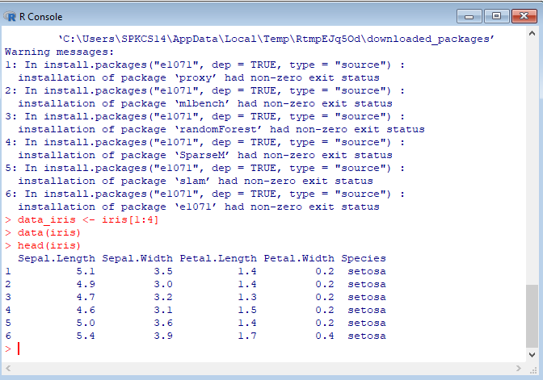

Output 2

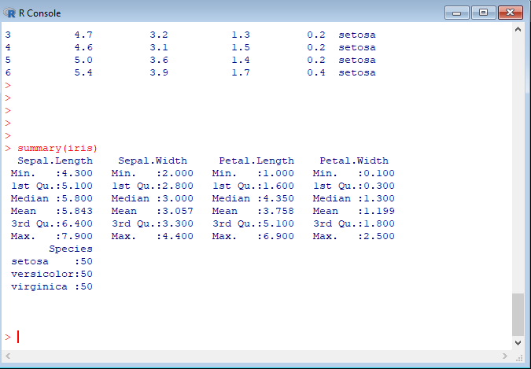

Output 3

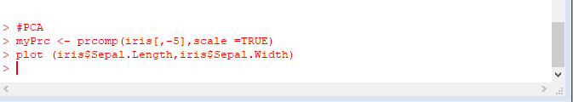

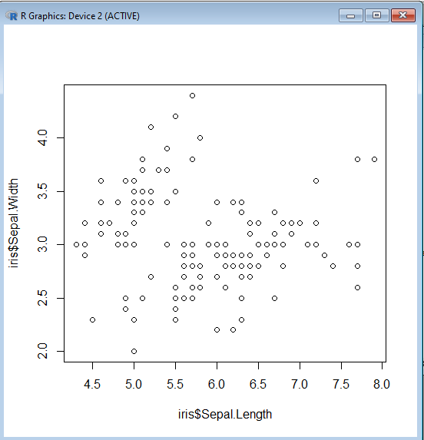

Output 4

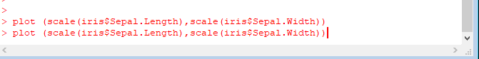

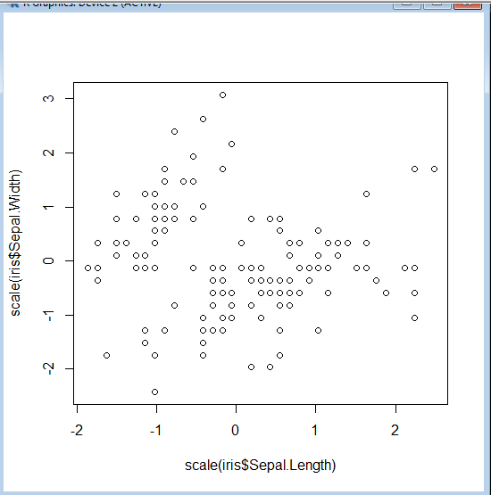

Output 5

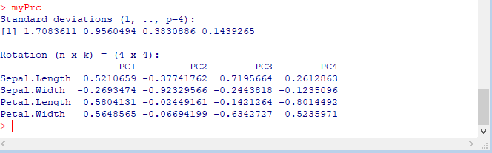

Output6

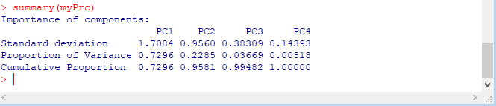



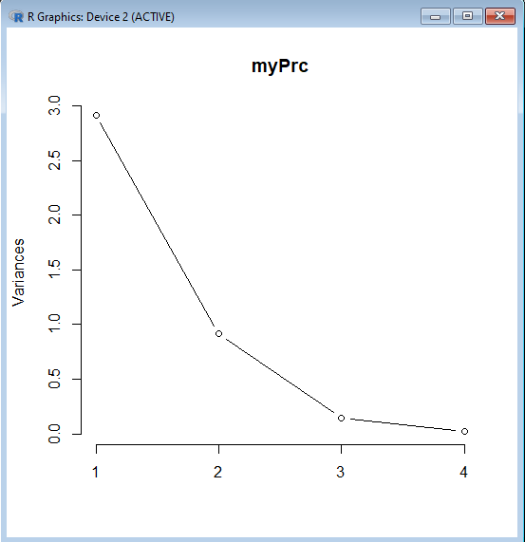

Output 7



